Acrotel Lily Ann Beach 3*, Elia  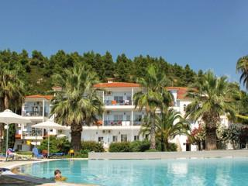 |  | de la 135 eur/pers in DBL garden view/sejur 5 nopti cu demipensiune | Acrotel Elea Beach 3*, Elia  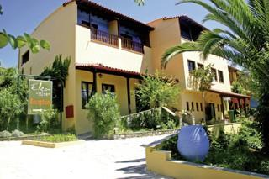 | de la 140 eur/pers in DBL/ sejur 5 nopti cu demipensiune
Alexander the Great 4*, Kriopigi  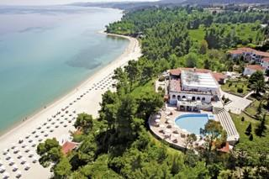 |  | de la 162 eur/pers in DBL garden view/sejur 5 nopti cu demipensiune | Porfi Beach 3*, Nikiti  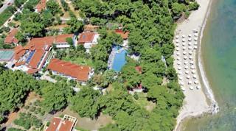 | de la 159 eur/pers in DBL promo/sejur 5 nopti cu mic dejun
Kassandra Palace 5*, Kriopigi  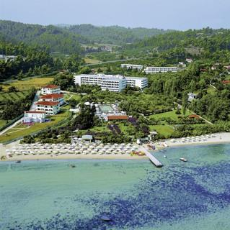 |  | 171 eur / pers in DBL mountain view / sejur 5 nopti cu mic dejun | Kassandra Palace 5*, Kriopigi  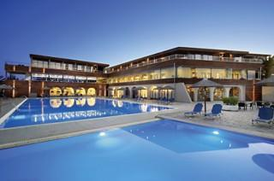 | 192 eur/pers in DBL/sejur 5 nopti cu demipensiune
Alia Palace Luxury 4*+, Pefkochori  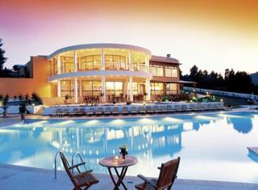 | 199 eur/pers in DBL sea side view/sejur 5 nopti cu demipensiune |  | Lagomandra Hotel & Spa 4*, Lagomandra  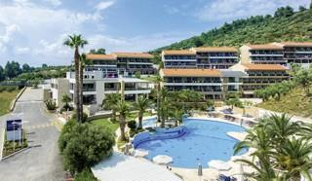 | 205 eur/pers in DBL sea side view/sejur 5 nopti cu demipensiune
Ekies All Senses 4*, Vourvourou  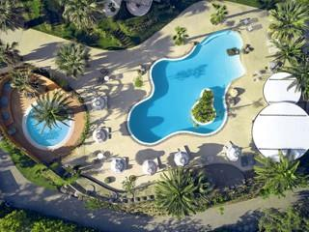 | 242 eur/pers in DBL /sejur 5 nopti cu demipensiune |  | Portes Lithos Luxury 5*, Nea Moudania  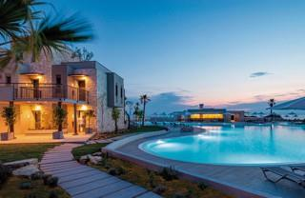 | 270 eur/pers in DBL sea side view/sejur 5 nopti cu demipensiune
Miraggio Termal Spa 4*, Paliouri  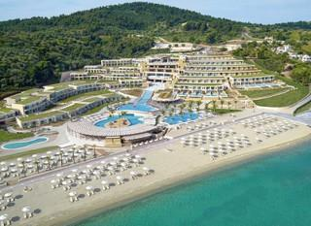 | 296 eur/pers in DBL /sejur 5 nopti cu mic dejun |  | Sani Beach 5*, Sani  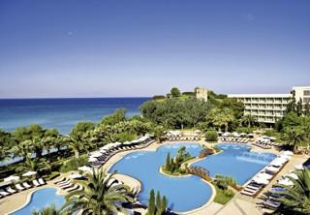 | 415 eur/pers in DBL eco/sejur 5 nopti cu demipensiune
Sani Club 5*, Sani  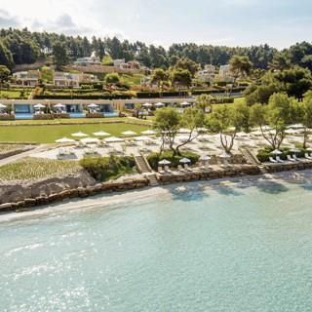 | 467 eur/pers in DBL garden view/sejur 5 nopti cu demipensiune |  | Sani Dunes 5*, Sani  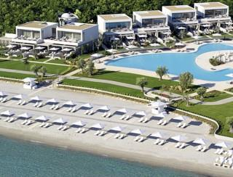 | 515 eur/pers in DBL promo/sejur 5 nopti cu demipensiune
Ikos Oceania 5*, Nea Moudania  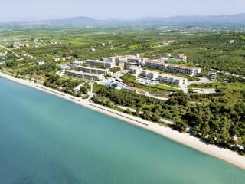 | 614 eur/pers in DBL eco/sejur 5 nopti cu all inclusive |  | Ikos Olivia 5*, Gerakini  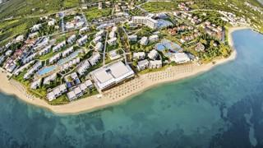 | 646 eur/pers in DBL promo/sejur 5 nopti cu all inclusive
Sani Asterias 5*+, Sani  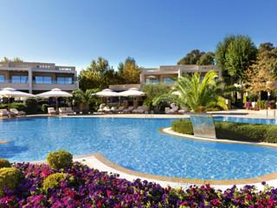 | 652 eur/pers in JRS marinafront/sejur 5 nopti cu mic dejun |  | Porto Sani 5*, Sani  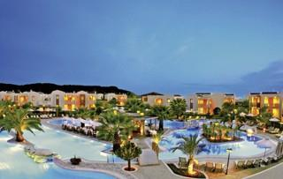 | 723 eur/pers in Suite promo/sejur 5 nopti cu pensiune completa
PERIOADA: 30.04-05.05.2021

